## Minerva: Enabling Low-Power, Highly-Accurate Deep Neural Network Accelerators

### Corresponding author

Brandon Reagen, Harvard University

David Brooks, Harvard University

### Keywords

Neural Network;

### Summary

#### Challenge

The continued success of Deep Neural Networks (DNNs) in classification tasks has sparked a trend of accelerating their execution with specialized hardware. While published de- signs easily give an order of magnitude improvement over general-purpose hardware, few look beyond an initial implementation.

#### Contribution

This paper presents Minerva, a highly automated co-design approach across the algorithm, architecture, and circuit levels to optimize DNN hardware accelerators. The accelerator consists of **FIVE STAGEs**: 1) Training Space Exploration. 2) Microarchitecture Design Space. 3) Data Type Quantization. 4) Selective Operation Pruning. 5) SRAM Fault Mitigation.

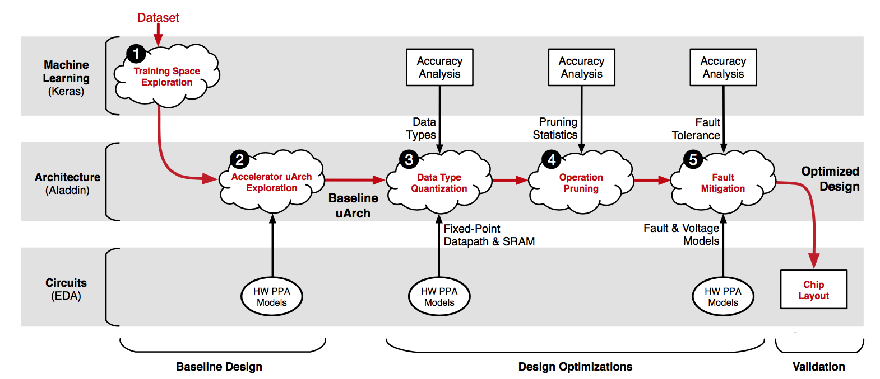

**Stage 1: Training Space Exploration.** Minerva first establishes a fair DNN baseline that achieves prediction accuracy comparable to state-of-the-art ML results. This stage leverages the Keras software library to sweep the large DNN hyperparameter space. Of the thousands of uniquely trained DNNs, Minerva selects the network topology that minimizes error with reasonable resource requirements.

**Stage 2: Microarchitecture Design Space**. The optimal network from Stage 1 is then fed to a second stage that thoroughly explores the accelerator design space. This process exposes hardware resource trade-offs through microarchitectural parameters (e.g., clock frequency and memory bandwidth). Minerva then uses an optimal design point as the baseline implementation to which all subsequent optimizations are applied and compared against.

**Stage 3: Data Type Quantization**. Minerva optimizes DNN data types with linear quantization analysis, independently tuning the range and precision of each DNN signal at each network layer. Quantization analysis minimizes bitwidths without exceeding a strict prediction error bound. Compared to a 16 bit fixed-point baseline, data type quantization reduces power consumption by 1.5×.

**Stage 4: Selective Operation Pruning**. The DNN kernel mostly comprises repeated weight reads and MAC operations. Analysis of neuron activity values reveals the vast majority of operands are close to zero. Minerva identifies these neuron activities and removes them from the prediction computation such that model accuracy is not affected. Selective pruning further reduces power consumption by 2.0× on top of bitwidth quantization.

**Stage 5: SRAM Fault Mitigation**. By combining inherent algorithmic redundancy with low overhead fault mitigation techniques, optimization Stage 5 saves an additional 2.7× power by aggressively scaling SRAM supply voltages.

The first stage is **software level** acceleration and is examined using Keras. The second to fifth stage belong to **architecture level** acceleration which automates a large design space exploration of micro-architectural parameters used for accelerator design. By using Aladdin, a simulation model is build. Beyond there is also a **circuit level** acceleration using EDA to verify the simulation result from software level and architecture level.

#### Result

Experiments show that these five-stage-optimization provide a collective average of 8.1× power reduction over an accelerator baseline without compromising DNN model accuracy.

Minerva enables highly accurate, ultra-low power DNN accelerators (in the range of tens of milliwatts), making it feasible to deploy DNNs in power-constrained IoT and mobile devices.